Assignment 1 Report - Heart Disease Prediction

1. Introduction
In this assignment, I use the UCI Heart Disease (Cleveland) dataset to build supervised learning models that predict whether a patient has heart disease based on routinely collected medical attributes.

1.1 Problem Definition
I formulate a binary classification task. The original target variable (num) indicates heart disease diagnosis severity on a 0–4 scale, where 0 represents no disease and 1–4 represent increasing levels of disease. For this assignment, I convert the target into a binary outcome: 0 = no heart disease and 1 = presence of heart disease. The goal is to learn a mapping from patient attributes (demographics, symptoms, and test results) to this binary label and evaluate predictive performance on a held-out test set.

1.2 Dataset Description
The dataset contains 14 commonly used attributes and one target label. The predictors include a mixture of:
- Continuous clinical measurements (age, resting blood pressure, serum cholesterol, maximum heart rate, ST depression),
- Binary indicators (sex, fasting blood sugar > 120 mg/dl, exercise-induced angina), and
- Categorical variables encoded as integers (chest pain type, resting ECG results, ST slope, number of major vessels, thalassemia status).
The workflow includes data cleaning, appropriate encoding/standardization, and model training. Following the assignment requirements, we compare a Naive Bayes classifier (generative approach) with linear regression–based classifiers (discriminative approach using a 0.5 threshold), and report accuracy, confusion matrices, and additional classification metrics.

2. Data Cleaning
2.1 Handling Missing Values
I first inspected the dataset for missing values. The original dataset contained 303 observations. Missing values (coded as “?”) were present only in two categorical variables:
- ca (number of major vessels): 4 missing values
- thal (thalassemia status): 2 missing values
In total, 6 observations contained incomplete information. I removed these rows using a complete-case approach, resulting in a cleaned dataset with 297 observations.

2.2 Addressing Noisy or Inconsistent Values
I examined summary statistics for continuous variables including age, resting blood pressure (trestbps), serum cholesterol (chol), maximum heart rate (thalach), and ST depression (oldpeak). All values fell within medically plausible ranges and no extreme or invalid entries were detected.
I also verified that categorical and binary variables contained only valid codes. No inconsistent category values were found. Therefore, no additional data corrections were necessary beyond removing incomplete records.

2.3 Justification of Cleaning Choices
Because only 6 out of 303 observations (~2%) contained missing values, I chose to remove these records rather than apply imputation. Imputing categorical variables such as ca and thal could introduce bias by artificially altering class distributions.
Given the small proportion of missing data, complete-case deletion was a simple and statistically reasonable choice that preserved data integrity while minimizing modeling assumptions.

3. Feature Engineering
3.1 Variable Types
The dataset contains a mixture of continuous, binary, and categorical features.
- Continuous variables: age, trestbps, chol, thalach, oldpeak
- Binary variables: sex, fbs, exang
- Categorical variables (integer-coded): cp, restecg, slope, ca, thal

3.2 Standardization of Continuous Variables
I applied Z-score standardization to all continuous variables, centering features at zero with unit variance. Standardization was chosen for three main reasons.
3.2.1 Different measurement scales
Continuous variables are measured on different units (e.g., cholesterol in mg/dL, heart rate in beats per minute). Without scaling, variables with larger magnitudes could disproportionately influence linear models.
3.2.2 Stability in linear models
Linear, Ridge, and Lasso regression are sensitive to feature scale because regularization penalties depend on coefficient magnitude. Standardization ensures fair regularization across features.
3.2.2 No need for normalization or log transformation
Min–max normalization was not used because the data do not require bounded scaling (e.g., [0,1]). Standardization preserves distributional shape while improving numerical stability.
Exploratory analysis showed that most continuous variables were approximately symmetric, with only mild right skewness. Therefore, no log transformation was applied.
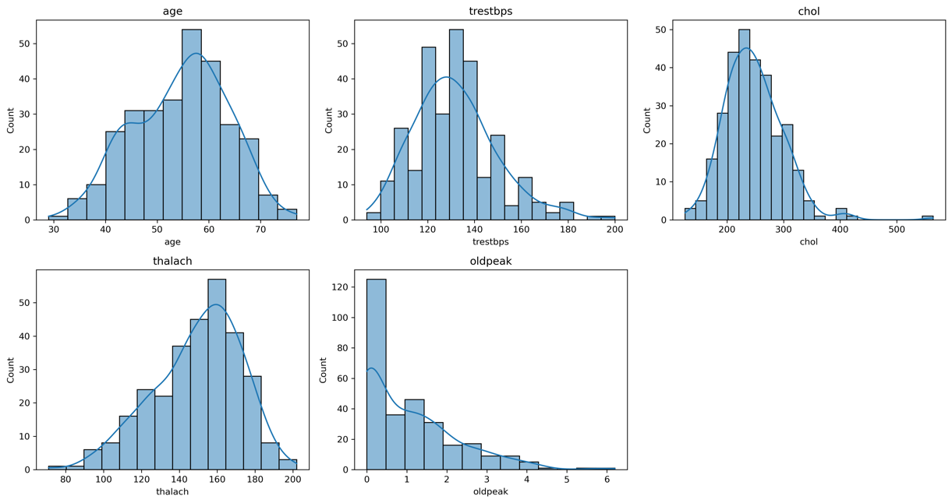
3.3 Encoding of Categorical Variables
Categorical variables were transformed using one-hot encoding. Although encoded as integers in the dataset, these values represent distinct categories rather than ordinal relationships. Using raw integer codes would incorrectly imply numerical ordering (e.g., cp=4 > cp=1). One-hot encoding prevents the model from assuming such artificial structure.
Binary variables were retained as 0/1 indicators and required no transformation.

3.4 Prevention of Data Leakage
All preprocessing steps were implemented within a ColumnTransformer and integrated into a Pipeline. The dataset was split into training and testing sets prior to fitting preprocessing parameters. This ensures that scaling and encoding were learned exclusively from the training data, preventing data leakage.

4. Model Comparison: Training Setup and Evaluation Results
4.1 Training Setup
After completing data cleaning and feature engineering, I split the dataset into training and testing sets using an 80/20 split with a fixed random seed to ensure reproducibility. The same split was used for all models to ensure a fair comparison.
All preprocessing steps (standardization of continuous variables and one-hot encoding of categorical variables) were incorporated into a preprocessing pipeline. This pipeline was fitted only on the training data and then applied to the test data to prevent data leakage.
The following models were trained and evaluated:
Gaussian Naive Bayes (GaussianNB) with
- var_smoothing = 1e−9
- var_smoothing = 1e−5
Linear Regression (used as a classifier with threshold 0.5)
- Ridge Regression (L2 regularization) with α = 1 and α = 10
- Lasso Regression (L1 regularization) with α = 0.01 and α = 0.1

4.2 Gaussian Naive Bayes
Both GaussianNB models (var_smoothing = 1e−9 and 1e−5) produced identical results:
- Accuracy: 0.867
- Classification performance:
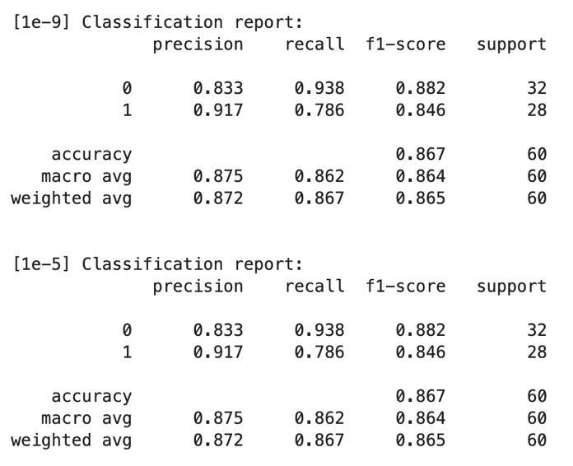
- Confusion matrix:
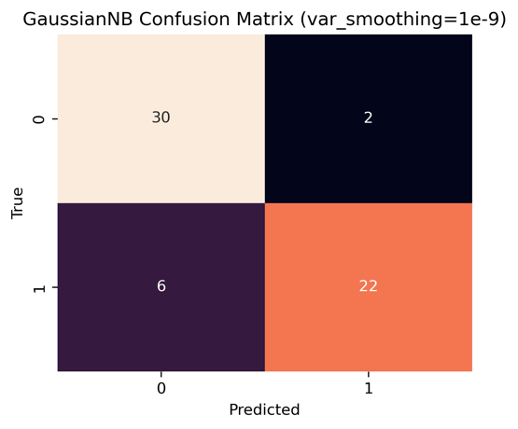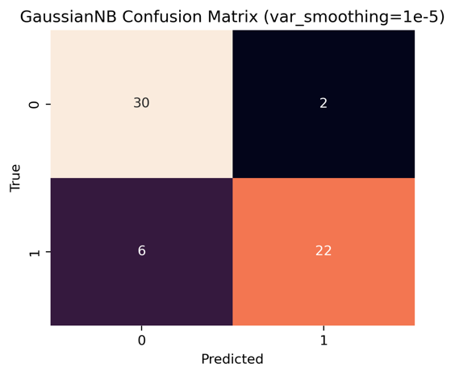
- AUC: 0.939
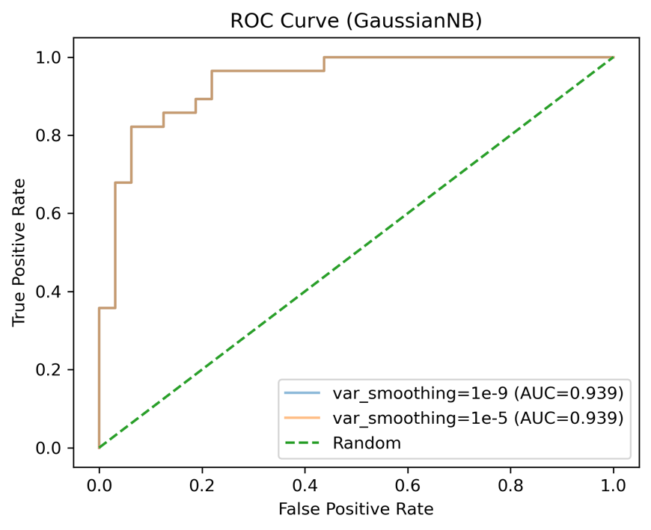
Changing the var_smoothing parameter did not affect performance. This suggests that the dataset does not suffer from numerical instability or near-zero variance issues, and the Gaussian assumption remains stable under both settings.

4.3 Linear-Based Models
Accuracy Comparison
- Linear Regression: 0.817
- Ridge (α = 1): 0.817
- Ridge (α = 10): 0.817
- Lasso (α = 0.01): 0.833
- Lasso (α = 0.1): 0.783
Ridge models with α = 1 and α = 10 produced identical accuracy to standard Linear Regression (0.817). This suggests that L2 regularization did not meaningfully alter model performance in this dataset. The features may not exhibit strong multicollinearity or overfitting issues that require L2 penalization.
Lasso with α = 0.01 slightly improved accuracy to 0.833, indicating that mild L1 regularization may help by shrinking or removing less informative features. However, increasing regularization strength (α = 0.1) reduced accuracy to 0.783, suggesting that excessive penalization leads to underfitting.
Based on performance comparison, Linear Regression and Lasso (α = 0.01) were selected for further evaluation.
• Classification performance:
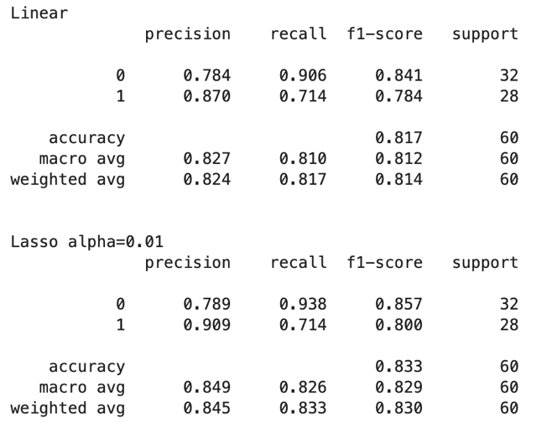
• Confusion matrix:
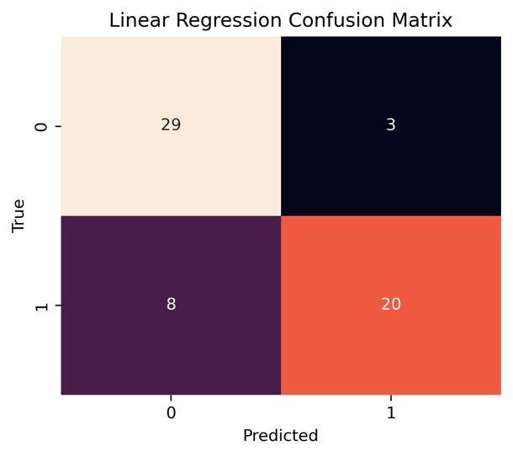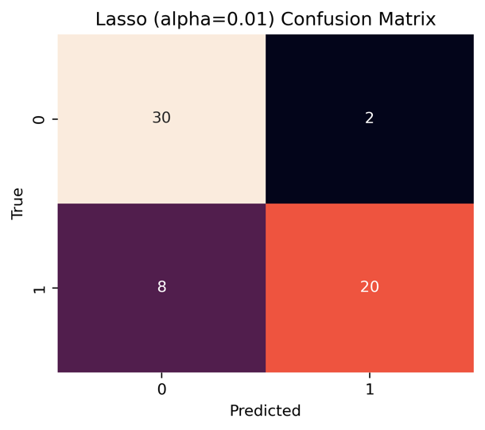
- AUC & ROC Curve
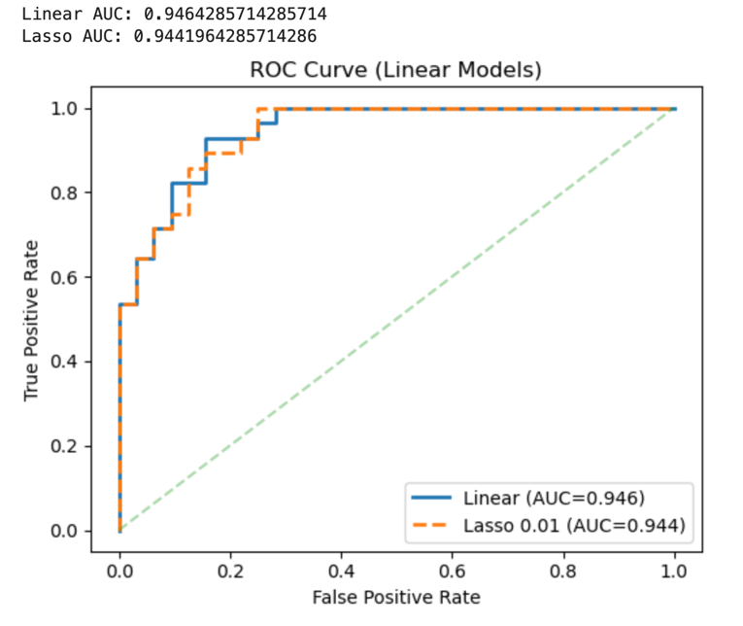
4.5 Overall Comparison
- All models performed strongly (AUC > 0.93).
- GaussianNB achieved the highest accuracy (86.7%).
- Linear models achieved slightly higher AUC values.
- Mild L1 regularization (Lasso α = 0.01) improved performance, while stronger regularization reduced it.
- L2 regularization (Ridge) had minimal impact.
Overall, the medical attributes in the UCI Heart Disease dataset provide strong predictive signal, and both generative (GaussianNB) and discriminative (linear) approaches perform well on this task.

5. Discussion: Interpretation and Limitations
5.1 Interpretation of Results
All models achieved strong predictive performance, indicating that the selected medical attributes contain meaningful information for identifying heart disease.
GaussianNB achieved slightly higher classification accuracy, while linear models produced comparable or slightly higher AUC values. This suggests that both generative and discriminative approaches are capable of capturing the overall signal structure in the dataset.

5.2 Model Suitability
A key limitation of this study is the use of Linear Regression for a binary classification task. Linear Regression is designed for continuous outcomes and does not constrain predictions to the interval [0,1]. Although a 0.5 threshold was applied to convert predictions into class labels, the model does not naturally produce calibrated probabilities.
In contrast, Logistic Regression would be theoretically more appropriate because it models the log-odds of class membership, it constrains predicted probabilities between 0 and 1, and it is specifically designed for binary classification.

5.3 Additional Limitations
5.3.1 Small sataset size
The dataset contains about 300 usable observations. With only 60 test samples, performance estimates may vary depending on the train–test split.
5.3.2 Independence assumption in GaussianNB
GaussianNB assumes conditional independence between features, which may not hold in medical data where variables such as age, blood pressure, and cholesterol can be correlated.
5.3.3 Single split evaluation
The analysis relies on one train–test split. Cross-validation would provide more stable and robust performance estimates.

6. AI Tool Usage Disclosure
I used ChatGPT as an auxiliary tool during this assignment. ChatGPT was primarily used to assist with generating and organizing portions of the model training code (e.g., setting up pipelines, implementing GaussianNB, Linear, Ridge, and Lasso models), formatting visualization code for confusion matrices and ROC curves, assisting in drafting and refining sections of the written report for clarity and structure.
The data preprocessing steps, including data cleaning decisions, feature engineering design, and variable selection, were completed independently. Model selection decisions, evaluation comparisons, interpretation of results, and the overall logical structure of the report were my own work. I verified, tested, and modified all AI-generated code to ensure correctness and understanding.

